02.04.07 Presentation (short process documentation)

In this assignment, we were tasked with handing a interactive poster for a movie from a list of 10 classical movies. The idea behind the interactive poster was to entice cinema goers who haven’t seen these films to go and visit the cinema to watch the movie.

## Collaboration agreement

The first thing we did as group was create a collaboration agreement, so that our focuses, desires, ambitions and goals aligned. We also set out some general rules, like how we would take decisions etc. WE also used the collaboration agreement to decide which movie we’d and decided to go with Wizard of Oz from the list of movies provided for us with regards to the task.

## Moodboard

In our moodboard, we decided to use stills from the along with icons and other accessory images. The mood that became apparent to us the use of colour and imagery in this film.

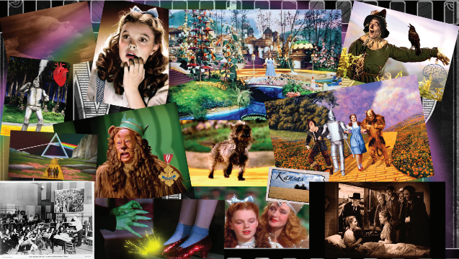

## Personas collage

From the moodboard we decided to figure out who are our target group were for the interactive poster. We decided our ideal target group would be teenagers and young adults that have an interest in going to the movies to see a classical movie.

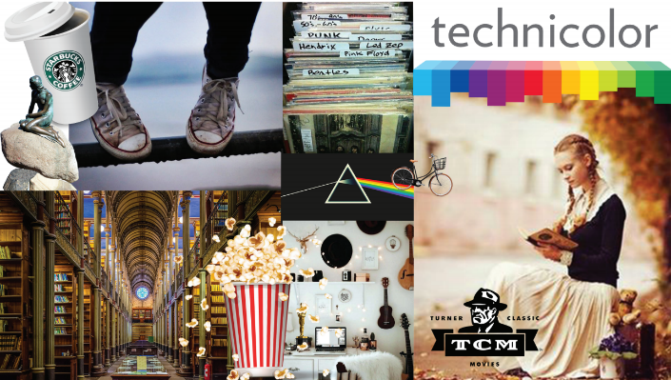

## Style tile

Then for our stile tile, we tried to focus on the clear separation of the grayscale and the coloured sections of the film. We plucked out colour scheme from two very opposing scene to find this contrast. We also decided on a font, which is called Oz’s Wizard. Its a style that mirrors the original title font of the wizard of oz movie. We decided on a style, which is flat design.

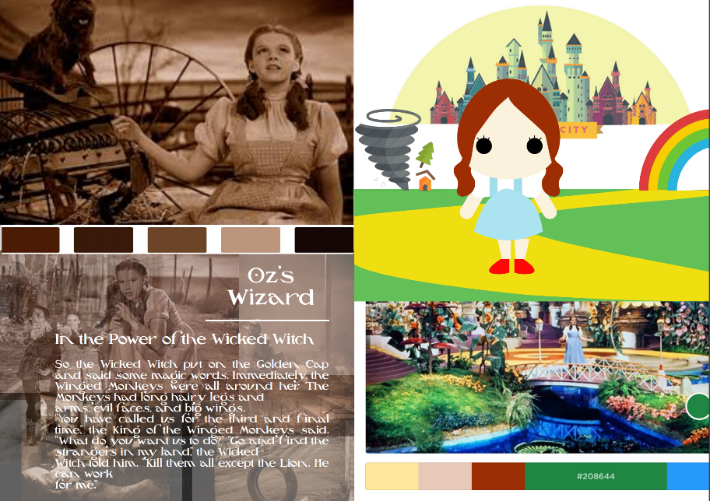

## Storyboard

   We created two storyboard, our first storyboard, was too movie specific, we tried to contain all the main scenes of the movie, the story generally seemed to have been held together with a thing string and was not well defined enough. Also the ending seemed a little sad and depressive, we believed that this would make the using

Thus we created a second storyboard that had a more clear purpose which was to tease the viewer and leave them wanting to go and see the film. In order to do that, we changed some scenes such as removing large amounts of text from the second scene. We also decided to keep the characters present before interaction, for the most part as this discouraged ambiguity in our scene, and finally we decided that the ending has to end on a climax which would make the user go to the cinema to see the film.

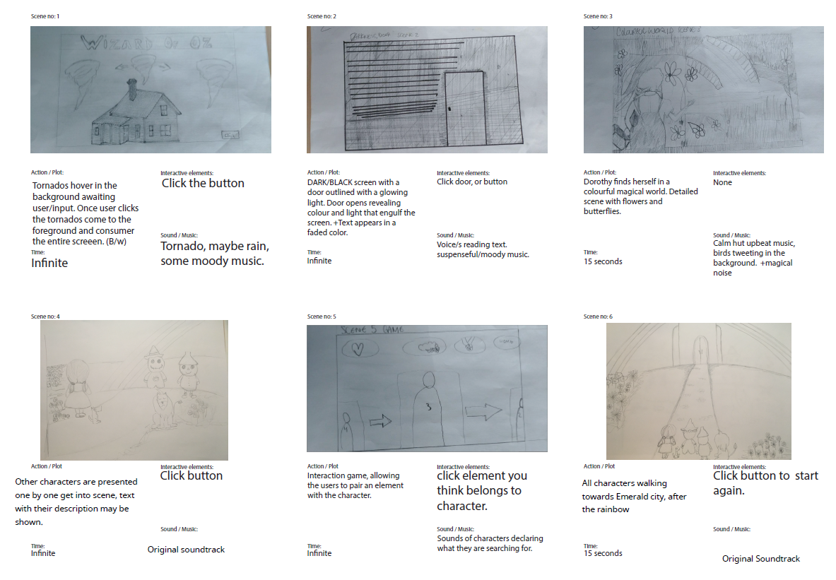

### Character designs

In our character designs we decided to stick to the style tile and we created characters based on the movie but using flat design. We did have to make some changes to the dog character, as the first version doesn’t really resemble a dog well. The second version of the dog makes much more sense (the lower dog in the example with the squared outline).

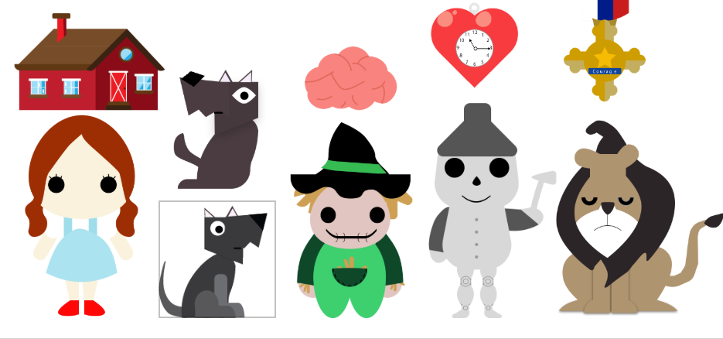

### Backgrounds

We also had process changes for our backgrounds, as the first version didn’t follow flat design principles with regards to colour and depth. Also our first set of background designs were based on the first storyboard so the second version fitted our story much better.

#### First version

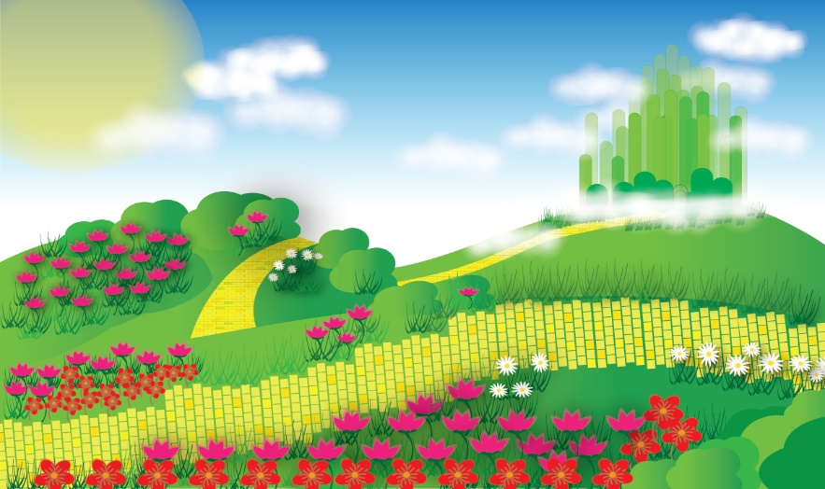

#### Second version

